Tackling Goodreads

Goodreads is the largest social network for readers in the world. A place for casual readers and bona-fide bookworms alike. Goodreads members recommend books, compare what they are reading, keep track of what they’ve read, form book clubs, enter giveaways, and much more. And the best yet is that EVERY SINGLE THING YOU DO ON GOODREADS LEAVES AN IMPRINT. This means there are endless possibilities of getting your book in front of readers eyes.

Firstly, join this group: https://www.facebook.com/groups/371827783200870/
If you have any issues with getting covers changed or other errors, this is the group you’ll need to go to. It can be incredibly difficult to get things changed or updated on Goodreads, so this group will become your new best friend.
Secondly, you’ll no doubt already know this but just in case, and I can’t stress this enough… NEVER COMMENT ON YOUR BAD REVIEWS! Just never do it. Comment on the good reviews by all means, but completely ignore negative ones. One man’s sess pit is another man’s hot spring. You, the author, will ALWAYS come out looking bad if you reply to any of them. Even a ‘I’m so sorry you didn’t enjoy the book.’ Is a bad thing to do. Everything you do on Goodreads leaves an imprint, and you do not want any imprints going to a negative review. Only positive ones.

THE BASICS:

- Claim your author profile. From there you can update your profile picture, write your bio, link your books, link to your blog, embed videos, post status updates, and more!
- ● Add the “Ask the Author” feature to your profile. This is an ongoing Q&A section where you can answer your fans’ questions at your leisure.
- ● Rate and review books so your followers can see what you’re reading.
- ● Add want-to-reads to your bookshelves.
- ● Since Goodreads is part of your online persona, stay positive and only post 5- star reviews. Use this platform to support your fellow authors rather than be critical.
- ● Add friends. Add friends via your social media platforms or email account and accept friend requests with abandon. It will help broaden your network.
- ● Find other authors similar to you and follow them. Comment on their books, add their books.
- ● Approach as a reader first and author second. Talk about other books. Be an expert in your genre.
- ● Set a reading goal for your readers to follow.
- ● Join a group related to your genre. Hang out there for a week or two and get to know the culture. Participate in book clubs and discussions. Engage!
- ● Like on Facebook and Twitter, don’t be aggressive promoting your book. People will come to you.

All of these things will leave an imprint and get you on to readers timelines!

GET IN FRONT OF MORE EYES.

Whatever you do on Goodreads leaves an imprint. Know this outright. Every single person that follows you will be able to see these imprints. If you leave a negative comment on something it will show up in the timeline of anyone who follows you. Therefore, only be positive.
If you LIKE a review on your book, or any book, it will show up in someone’s timeline.
If you COMMENT on a review on your book, or any book, it will show up in someone’s timeline.
If you ADD a book, it will show up in someone’s timeline.
Do you see where I’m going here?

So you need to utilize this, and you can do, in a few very easy steps.

- ADD your own book to your bookshelf. If the book is complete, add it to READ and any other shelves you think it fits. Remember, you can make as many shelves as you want and label them whatever you want. So if your book is a fast paced action thriller that is part of a series, make and then add it to the shelves – ACTION BOOKS, MY BOOKS, THRILLER BOOKS, PART OF A SERIES.
- If you are currently WRITING a book, ADD it to your CURRENTLY READING shelf, and then add it to all the other relevant shelves.
- Rate your own book. This might seem obnoxious, but in the mindset of a reader look at this way. If you don’t think your book is five stars, why would they? Also, it’s another thing that will pop up in readers timelines.
- Do these things at different parts of the day. ADD your book in the morning, RATE it in the afternoon, LIKE someone’s review of your book in the evening. That way you are hitting readers timelines continuously and they’re more likely to take notice.

OTHER THINGS YOU CAN DO

- If you’re currently writing a book, make sure to update how far along you are and leave a comment on it like, ‘That last chapter was hard because there was so much action, but I love writing those types of scenes.’
- Remember, every update gets you on to someone’s timeline and in front of a readers eyes.
- There’s also a little tab called ‘general update’. Use this! Update your readers with what you’re doing. It’s limited on what you can put so keep it short and snappy like, ‘Working on (insert) BOOK TITLE this week and searching for a cover image, but first COFFEE! What are you all up to? What are you currently reading?’
- BLOG at least once a month. Once a week if possible. Goodreads has a free blog you can utilize when you claim an author profile. Send out your blog NO LATER THAN THURSDAY. The blog goes out on Friday morning. This is another great way to get in front of readers, and for new readers to get to know you. Don’t worry about them being lengthy. Again, keep them short and snappy. The really great feature here is that you can actually add your book on Goodreads to your blog, so readers don’t need to go looking for your book, they can just click right to it and add it to their shelf.
- Every time someone interacts with you, or your book, it goes on to their timeline that their followers see. If they add your book, it shows on their timeline. If they rate your book, it shows on their timeline. If they ask you a question, it shows on their timeline! Every step puts you in front of more and more readers.
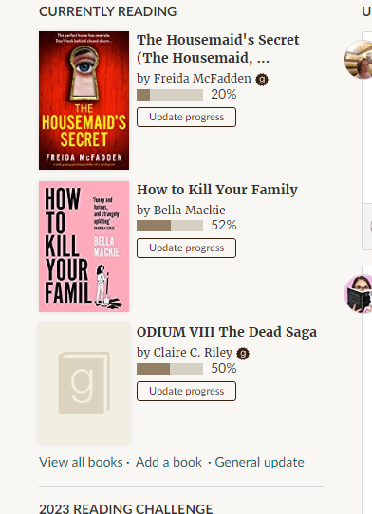

As you can see below, someone commented on my status update and so I replied. I also liked and commented on a review for one of my books. I answered a question someone left for me, and I even commented on Robs blog post. All of those things went on to the timeline of my followers, AND my timeline. This keeps me in front of them and relevant.

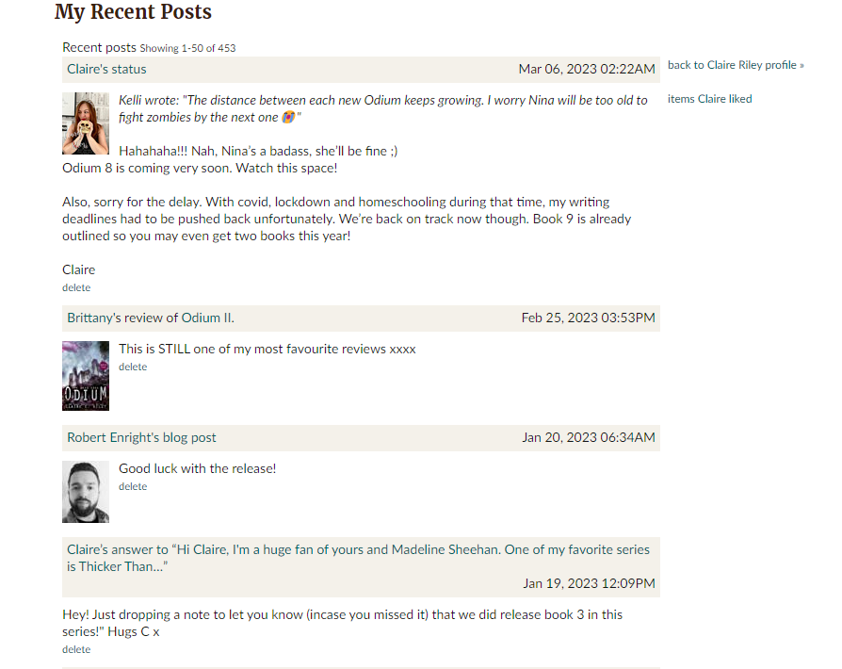

Below, is how your timeline looks. Reviews show up, likes show up, comments show up, friendships show up. Everything shows up. But it is constantly changing, so as previously stated, do things at different times of the day so that you show up more frequently.

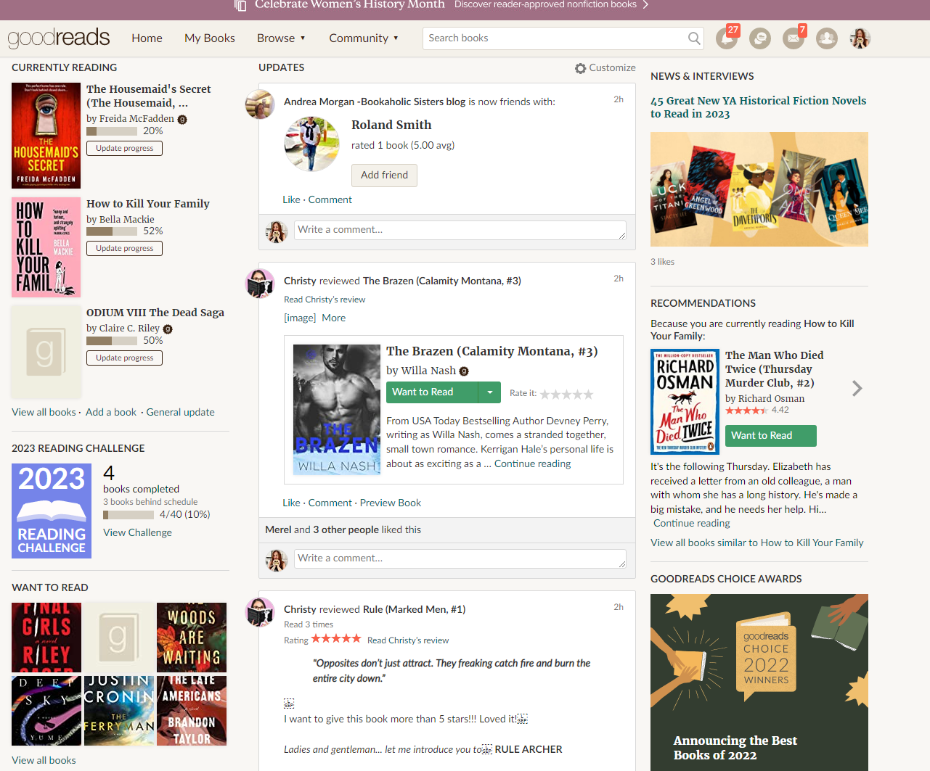

Blog post and Q&A page.

Don’t be disheartened if you don’t get many ‘likes’ on your blog posts. That doesn’t mean people aren’t reading it. People are predominantly lazy and when it shows up in their timeline, they read and move on. ALSO, Goodreads emails all of your follows your blog post. So they can read it directly from their email and therefore not ‘like’ the post.

Make sure to set up a brief – Ask me anything – so that readers can ask you questions, and make sure to actually reply to them.
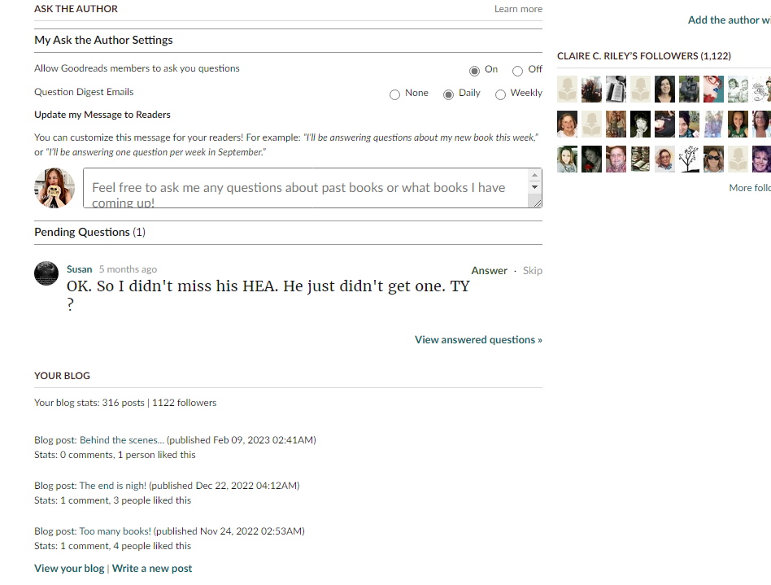

There are many more things you can do on Goodreads, including giveaways and making reading groups, voting on books, adding your books to lists and so on, but this should give you a brief introduction.

Hope this helps!

USA Today Bestselling Author
Claire C. Riley / C. Riley

